1/31/2019
Economic Report and Production Analysis for France

Heyang Huang, Soulaymane Kachani, Jiayu Zhao
Columbia University in the city of new york

Economic Report and Production Analysis for France

1. Report Overview

In this report, we aim to uncover the economic path France went through during the period from 2009 to 2014. Specifically, we dive into the topic through a macroeconomic overview of France from the perspective of Gross Domestic Product (GDP) and Economic Complexity Index (ECI), which reflect countries’ production capability and production structure, respectively. We then analyze the industrial framework and changes of France during the period based on quantitative measures such as Product Complexity Index (PCI) and Product Family Complexity Index (PfCI), followed by a detailed analysis of how such changes have matched with development strategies as quantitatively measured by opportunity gains on an industry-level. We conclude our report with macro-level results and predictions of France, as deduced from regression models we have established on a global scale, which takes into account countries’ stances in their product space.

2. Macroeconomic Results

2.1 GDP Ranking and Changes
As the 6th largest economy in the world by GDP, France has a GDP of 2.7 trillion USD in 2009 and 2.8 trillion USD in 2014, exhibiting an extraordinary level of economic output. Figure 1 illustrates the time-series GDP results for world’s leading economies from 1996-2016, and France ranks among its counterparts as a stable player. France exhibits a consistent level of GDP during the twenty years from 1996 to 2016, while its annual growth rate is only about 1.1%. This rate is clearly below the annual growth rate of the group of leading economies in the world, which have a geometric average growth rate of 5.1% and an arithmetic average growth rate of 5.2%. The annual growth rate of 1.1% is particularly in sharp contrast to an annual growth rate of 15.5% for China, one of the world’s most important emerging economies and France’s competitor in many industries. The stagnated economic growth in France, we believe, can be reflected through consistent ECI and PCI, and can be further explained by a suboptimal set of production strategies France adopted during the period, which we will expand at the later stage of the report.

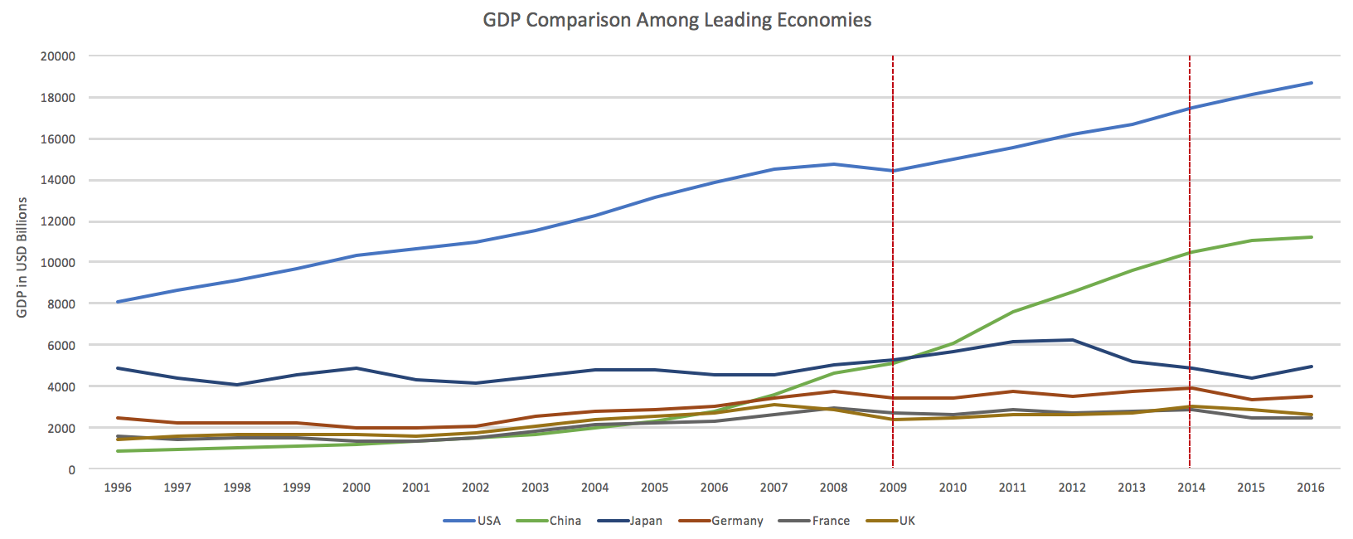

Figure 1: GDP Comparison Among Leading Economies

2.2 ECI Ranking and Changes
The Economic Complexity Index (ECI), as defined by Ricardo Hausmann and Cesar Hidalgo in 2009 to explain the knowledge accumulated in a country's population, exhibits similar pattern for France. As illustrated in Figure 2 below, France exhibits a stable but flat curve in terms of its production capability from 2009 to 2014, which is true for most of the developed economies. This is in direct contrast to countries such as China, which demonstrates overwhelming advantage over France in terms of both ECI and GDP growth during the period.

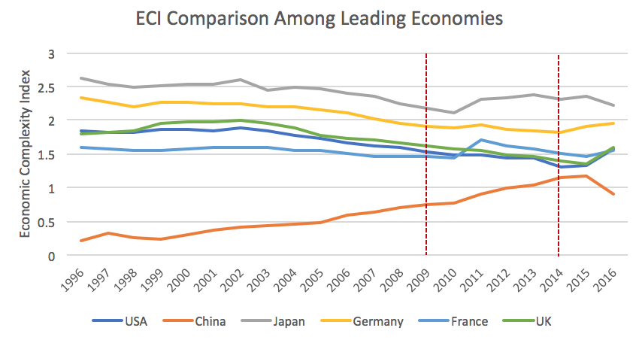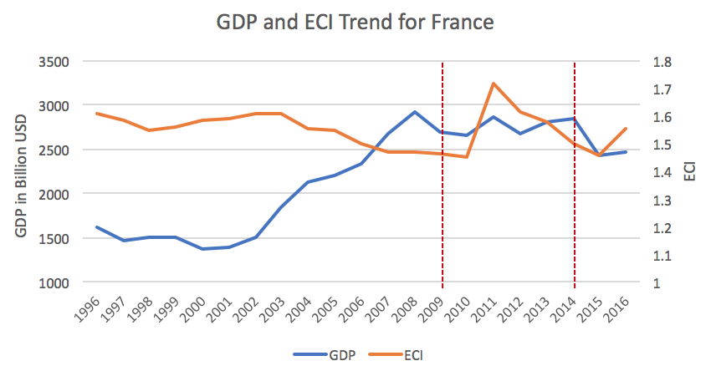

Figure 2: ECI Comparison Figure 3: GDP and ECI (France)

Figure 3 offers a further comparison of GDP and ECI over the entire time span from 1996 to 2016 for France. The stagnancy in GDP during the period from 2009 to 2014 is accompanied by a stagnancy in ECI, indicating the potential that the mild economic growth experienced by France during the period from 2009 to 2014 might be attributed to its slow-growing ECI, or the ineffectiveness of the country in developing a competitive product space that helps to accumulate complicated knowledge and technology. In order to provide a more concrete answer to why this has happened, we will dive into an analysis of France’s production structure and its product space designs in the next few chapters.

3. Production Analysis

3.1 Product Categorization
Our main data source in this research is the UN Comtrade Website (https://comtrade.un.org), which provides us with valuable information on countries’ export values on an annual basis, including highly specific export data for more than 5000 categories of products. In order to have a holistic vision of the product space of a country, however, a level of categorization is required. Product in our data source are labelled from 010000-999999, with the first two-digits representing a general category to which the product belongs. Based on the 99 categories as extracted from the label, we further group the products into 18 most widely-accepted industries, as summarized in Table 1.

Note that the high-tech industry group is not a distinct industry but rather an aggregated industry that encompasses the most complicated products from the most technologically-advanced industries (as measured by PCI). This industry serves as an indicator for us to quantitatively evaluate how well a country has performed in developing cutting-edge technologies and closing its technical gap with advanced economies, which has become a topic of wide concern today. Indeed, when we rank the 18 categories based on PfCI (an equivalent concept of PCI as calculated based on the 18 categorized product groups), high-tech industry has the highest PfCI among all industry groups.

Category | Description
Animal and By-product | All kinds of meat, livestock and related by-products
Vegetable, Fruit and Plant | All kinds of plants, edible vegetables and fruits
Food and Preparation | Edible preparations, raw cooking materials and appliances
Mineral and Stone | Mining industry for mineral and stone materials
Chemical | Raw chemical materials and by-products
Chemical Manufacturing | Advanced chemical products and pharmaceutical products
Raw Manufacturing | Basic products made from plastic, rubber, leather, etc.
Wood Product | Book, paper and other elementary products related to wood
Clothing and Accessory | All kinds of fabrics, filament, clothing and accessories
Textile | All kinds of textile articles and related products
Metal | Mining of all sorts of raw metal
Machinery | Machinery and mechanical appliances, including electrical equipment
Transportation | Vehicles and locomotives including aircraft, ship, railway, etc.
Weapon | Explosives, arms and ammunition
Daily Instrument | Basic daily instruments such as sport requisites, timing and measuring tools
Precious Stone | Refined or processed stone products such as pearl and ceramics
Service | Financial, business, legal, communication, travel services, etc.
High-tech | Agglomeration of advanced products with highest PCIs

Table 1: Categorization of Products

We further observe a strong positive correlation between the GDP and the export of high-tech products. As shown by Figure 4 below, a high adjusted R-square of 67.6% exists between GDP and high-tech exports, indicating that more successful economics, as measure by GDP, tend to be those that are capable of producing and exporting high-tech products as we define them.

Statistics | Value
Multiple R | 0.824
R-Square | 0.679
Adjusted R² | 0.676
Variable | Value
Coefficient | 12.20
t-stat | 15.61
P-value | 0(***)


Figure 4: Regression of GDP and High-tech Exports

3.2 Actual Development
Based on the product categorization aforementioned, we aim to capture France’s actual production strategy between 2009 and 2014 on a complexity level. In Hausmann and Hidalgo (2009), distance is defined to be a measure of how far a country is from a certain product not in its product space. We extend this concept to all product groups and quantify how technically equipped a country is to develop corresponding product groups. In other words, the shorter the distance between a country and a product group, the more capable a country is in developing products within that group. Defining this net distance change as the Actual Developmental Index (ADI), our export data allows us to calculate and compare ADI of France and the 18 product groups in 2009 and 2014 through subtraction, where a positive ADI indicates a shortening of the distance (i.e., advancement of the industry), and a negative ADI indicates the reverse. As ranked in Table 2, during the period from 2009 to 2014, France has focused on products with a moderate level of complexity and those requiring intermediate skills, including raw manufacturing, mineral and stone, which is unusual among developed economies.

Category | ADI | Category | ADI
1. Raw Manufacturing | -0.080 | 2. Mineral and Stone | -0.082
3. Precious Stone | -0.086 | 4. Chemical Manufacturing | -0.095
5. Chemicals | -0.102 | 6. Wood Product | -0.111
7. Clothing and Accessory | -0.113 | 8. Service | -0.114
9. Weapon | -0.114 | 10. Animal and By-product | -0.118
11. Vegetable, Fruit and Plant | -0.120 | 12. High-tech | -0.129
13. Food and Preparation | -0.134 | 14. Metal | -0.136
15. Textile | -0.147 | 16. Transportation | -0.178
17. Daily Instrument | -0.241 | 18. Machinery | -0.324

Table 2: Actual Developmental Index (ADI) of France

3.3 Regional and Global Comparison
Table 3 and 4 below summarizes how the production strategy adopted by France compares with other leading economies and a selected group of emerging economies in the world, as measured in ADI. It can be directly observed that France focused on products with a lower complexity level, when compared against its leading counterparts such as USA and Germany, which give a considerable level of attention to more advanced product groups such as clothing, service and chemical manufacturing.

Ranking | France | USA | Germany
1 | Raw Manufacturing | Service | Chemicals
2 | Mineral and Stone | Chemical Manufacturing | Service
3 | Precious Stone | Food and Preparation | High-tech
4 | Chemical Manufacturing | Textile | Transportation
5 | Chemicals | Clothing and Accessory | Food and Preparation

Table 3: ADI Comparison across Leading Economies

Ranking | China | South Korea | Singapore | India
1 | Precious Stone | Chemicals | Machinery | Daily Instrument
2 | Service | Machinery | Transportation | High-tech
3 | High-tech | High-tech | Daily Instrument | Wood Product
4 | Machinery | Weapon | Chemicals | Machinery
5 | Chemicals | Precious Stone | High-tech | Chemicals

Table 4: ADI Comparison across Emerging Economies

Table 4 further examines France’s development strategy against those of emerging economies on a global scale. Reasonably, emerging economics such as China, South Korea, Singapore and India have devoted the majority of their efforts into intermediate industry groups while developed economies such as France should have relied more on advanced industry groups. This trend holds true in general, regardless of the continent or the time period, and serves as an indicator for which phase of development a country is currently in as evaluated from their production strategy. Based on this standard, France is indeed adopting a moderate but slightly out-of-phase strategy that seeks development in industry groups with a lower level of complexity than it should.

4. Product Space Design

4.1 Suggested Development Vector
As aforementioned, distance gives us an idea of how far each new product is from a country’s current mix of exports. As defined in Hausmann and Hidalgo (2009), distance is “the weighted proportion of products connected to goods p that country c is not exporting, i.e., MCP=0.” Based on this definition, the distance between a country and any product that the country is currently exporting (i.e., the country is a significant exporter in the product as compared to global average) is zero. Similarly, opportunity gain quantifies the contribution of a new product in term of opening up the doors to more and more complex products. Intuitively, a product that a country is currently exporting (i.e., MCP=1) has an opportunity gain of zero. And unreasonable investment on certain product p would lead to a relative decrement in export of more profitable products, and therefore lead to a negative opportunity gain of product p. The opportunity gain is not the only estimator of a country’s level of economic development. However, among countries with comparable economics strength, those having higher ECI, or in other words, more reasonable economics structure is often in better shape.

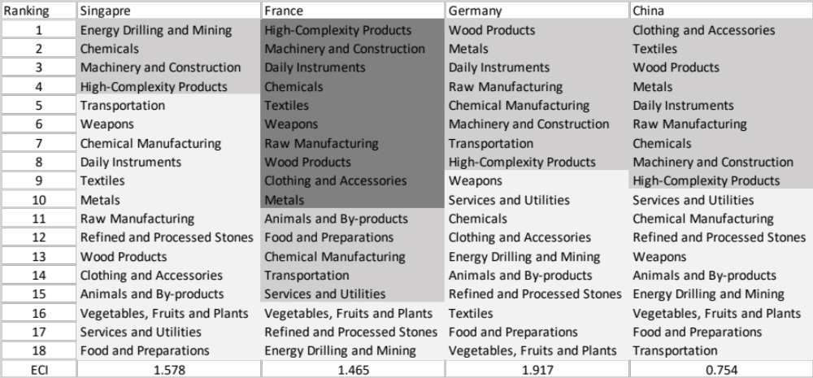

Table 5: Opportunity Gain Ranking on a Global Scale

We define the ranking of opportunity gain for a country c, as the Suggested Development Vector (SDV) of c. Table 5 summarizes how the SDV of France compares with a selected group of leading economies in the world, with the industry groups ranked in decreasing order of significance. Dark grey indicates positive opportunity gain, gray indicates zero opportunity gains, and light grey indicates negative opportunity gains. The result shows that leading countries barely have any industries with positive opportunity gain. In other words, those countries are already in the most stable and efficient economic structure. Without the necessity of economic transition, those countries merely need to maintain a steady and balanced economic development. In contrast, African countries have nearly half of industries with positive opportunity gain, and share common interests in industrial manufacturing and high-tech industries (shown below in Table 5). It can be concluded that France, as a developing country, shares the characters of developed countries, with a balanced economics structure that leans towards high-end industries. At its current stage, France has no industries that are extremely under-developed and highly profitable.

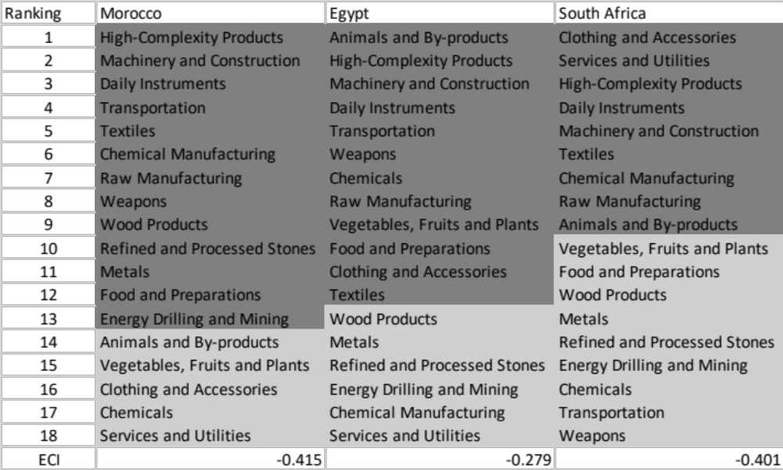

Table 5: Opportunity Gain Ranking on a Global Scale (Continued)

4.2 Sensitivity Analysis and Contingency Strategy

Since the previous result shows that France is an advanced emerging economy with no obvious deficiency in terms of industry structure, a sensitivity analysis is performed by incrementally or decrementally altering the export of an industry by percentage, and calculating the correspondent change of ECI and SDV, in order to identify industries that have played particular important roles for an economy. For a given pair of country and industry, the sensitivity analysis aims to approximate the volatility of SDV subject to an instant increment or decrement of export and is mainly implemented on developed countries that have few industries with positive opportunity gains. In contrast, developing countries have positive opportunity gains in most of their industries and the result of sensitivity analysis is consistent with the first iteration of sequential development strategy, which is our primary tool for analyzing developing economies.

Since France assembles developed economies, as shown by prior results in section 4.1, sensitivity analysis is adopted here to better interpret its development. When the opportunity gain of the industry is negative, the sensitivity analysis approximates how an over-development of the industry jeopardizes the economic structure of a country. When the opportunity gain of the industry is zero, the sensitivity analysis determines whether the further development of the industry shapes the country a better economic structure, and predicts how the SDV would change accordingly. Specifically, as we reduce the export of such an industry to 25%-50% of its original value, a few other industries originally with negative opportunity gain would probably become profitable. Instead of compensating for the decreasing export of the declining industry, the best strategy is to develop those incipient profitable industries. In this manner, we can derive the contingency strategy for countries to deal with possible abrupt declines of crucial industries. In some cases, the SDV remains unchanged even when a zero-opportunity-gain industry declines to its 20% in terms of export. We can then conclude the industry is not indispensable to the country.

We perform the sensitivity analysis of the aggregate of top ECI countries, including US, UK, Korea, Japan, South Korea, Singapore, Germany, and France, and use the result as the benchmark. The sensitivity score in 2014 and 2009 are shown in Table 7 and Table 8 respectively:

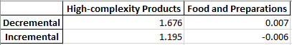

Table 7: Sensitivity Score of the Aggregate of Developed Countries 2014

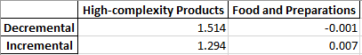

Table 8: Sensitivity Score of the Aggregate of Developed Countries 2009

In summary, High-complexity Products exerts great impacts on economics structure of top countries. Such countries are extremely vulnerable to High-complexity Products industry declines, and benefit from High-complexity Products prosperity. In contrast, ECI is not highly sensitive to shift of Food and Preparations industry.
We observe a similar pattern that the Sensitivity Score of Food and Preparations is approximately zero, while the Decremental Sensitivity Score is larger than the Increment. We can therefore make three conclusions here.
- The disturbance in Food and Preparations industry exert a trivial impact on the E_{f}CI of a country, which echoes with our intuition that Food and Preparations is of minimal significance to the structure of product space of developed countries or fast developing countries.
- The High-complexity Products industry is the cornerstone industry of most developed or fast developing countries.
- The reward of an increase of High-complexity Products production is less than the jeopardy of a decrease in the same extent.

Besides the sensitivity score, we are interested in the shift of SDV caused by upheavals in different industries. The shift of SDV gives us a good vision of how the production pattern will be affected. The results of Benchmark in 2014 are shown below in Table 9-Table 16

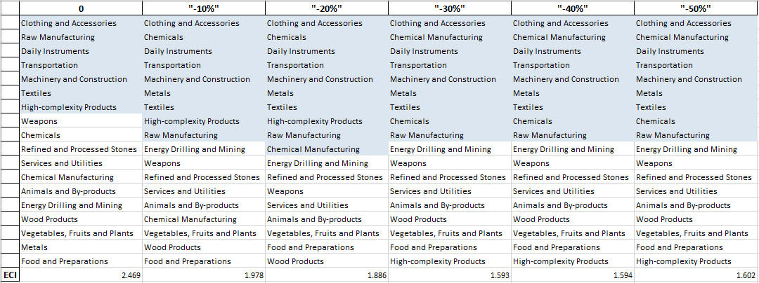
.

Table 9: Aggregated High-complexity Products 2014( Decremental Sensitivity)

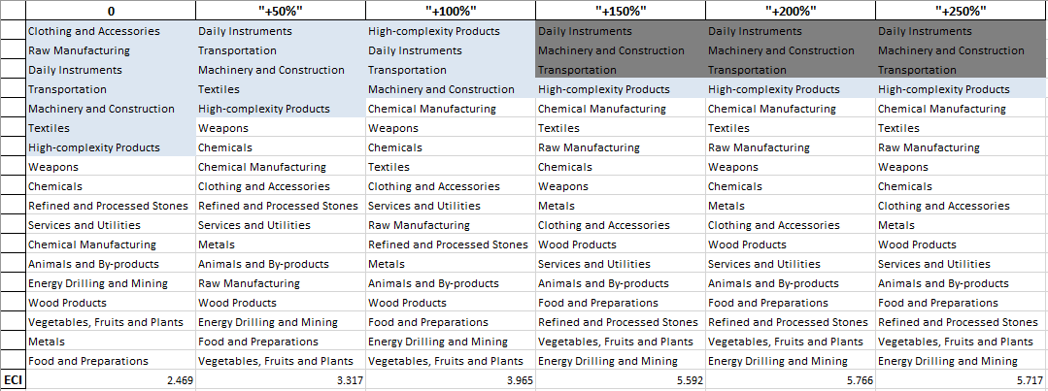

Table 10: Aggregated High-complexity Products 2014( Incremental Sensitivity)

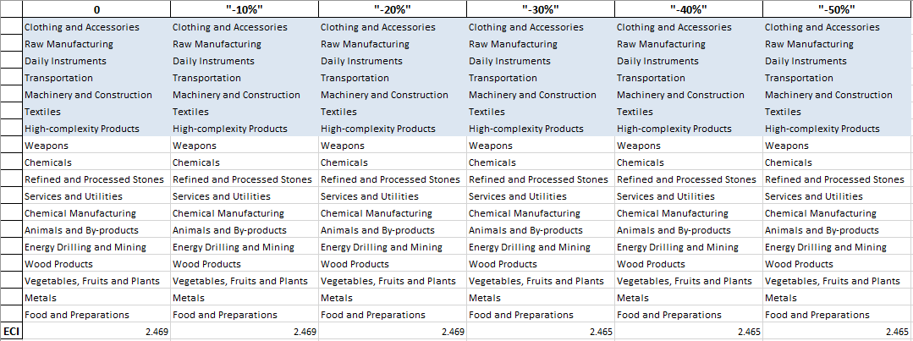

Table 11: Aggregated Food and Preparations 2014( Decremental Sensitivity)

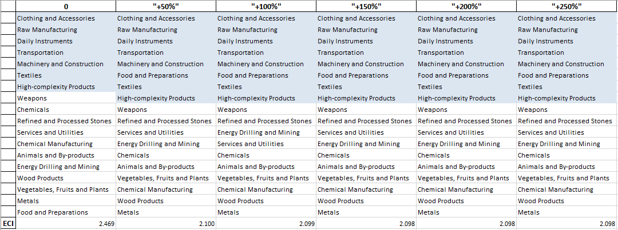

Table 12: Aggregated Food and Preparations 2014( Incremental Sensitivity)

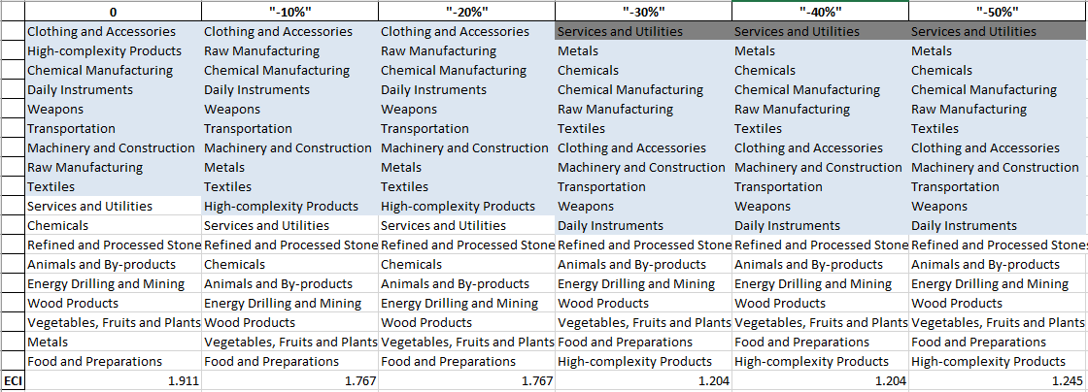

Table 13: Aggregated High-complexity Products 2009 ( Decremental Sensitivity)

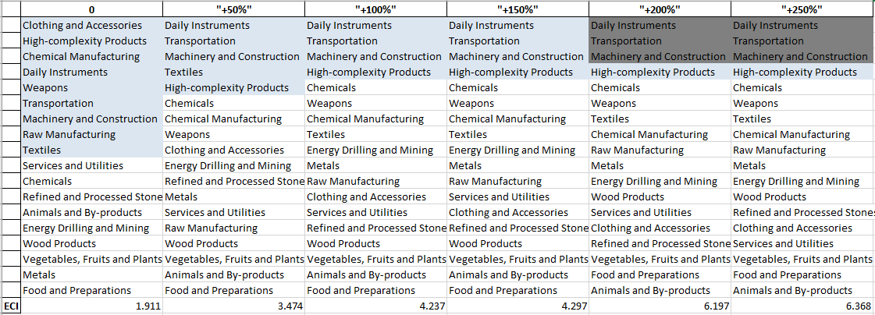

Table 14: Aggregated High-complexity Products 2009 ( Incremental Sensitivity)

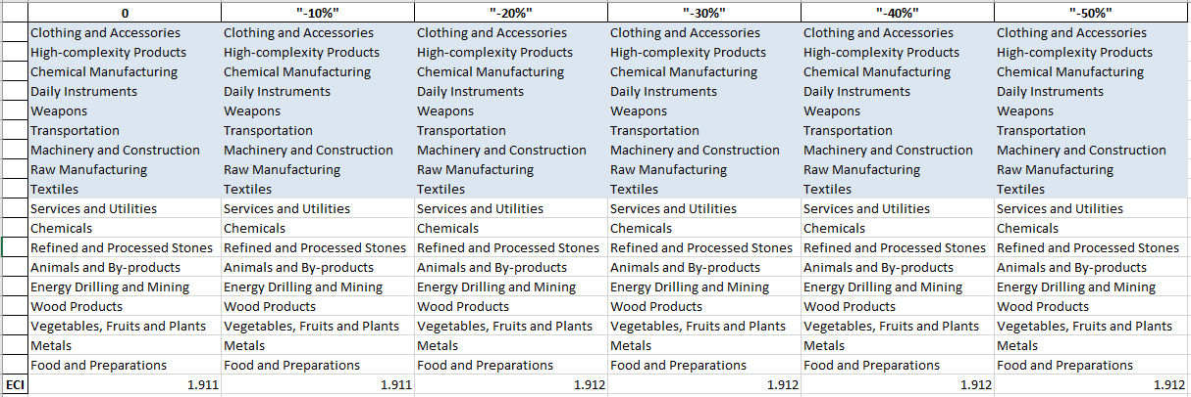

Table 15: Aggregated Food and Preparations 2009 ( Decremental Sensitivity)

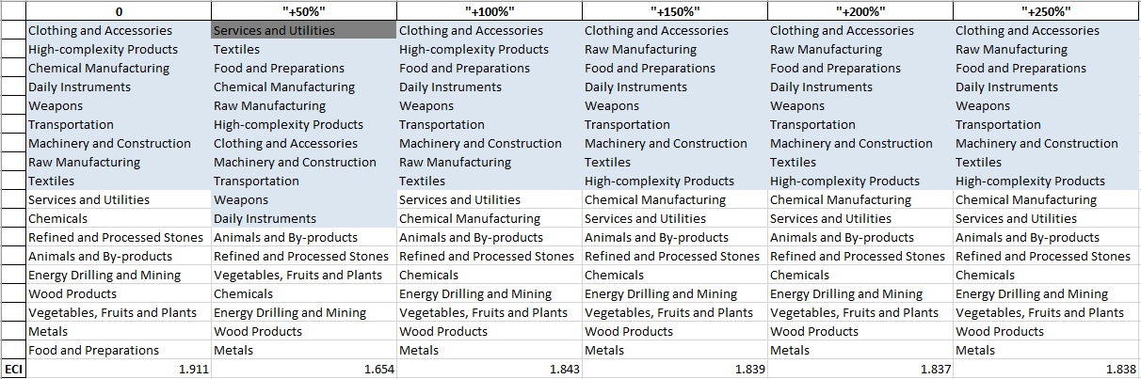

Table 16: Aggregated Food and Preparations 2009 ( Incremental Sensitivity)

The Contingency Plan aims to present a set of solutions with respect to upheavals in different industries. Instead of compensating for the declining production directly, the best strategy is to develop those incipiently profitable industries. In this manner, we can derive the contingency strategy for countries to deal with possible abrupt declines of crucial industries. In some cases, the SDV remains unchanged even when a zero-opportunity-gain industry declines to its 20% in terms of export. We can then conclude the industry is not indispensable to the country. As a clarification, the three consecutive N/As means that the country doesn’t even need to respond to a collapse in the industry. Countries tend to have distinct solutions to the up and down of the same industry.

4.3 Result and interpretation

The sensitivity analysis of France ends up with the results below.

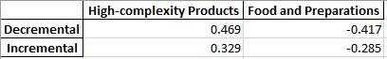

Table 17: Sensitivity Score of France 2014

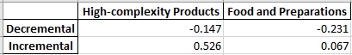

Table 18: Sensitivity Score of France 2009

The High Tech industry conforms to the pattern of the aggregate of top developed countries. However, France is relatively less sensitive to High Tech. Moreover, food and Preparation is not essential to the ECI of France. Current export of Food and Preparation is unbalancedly high compared to other industries, since a decrement of it turns out to increase the ECI.

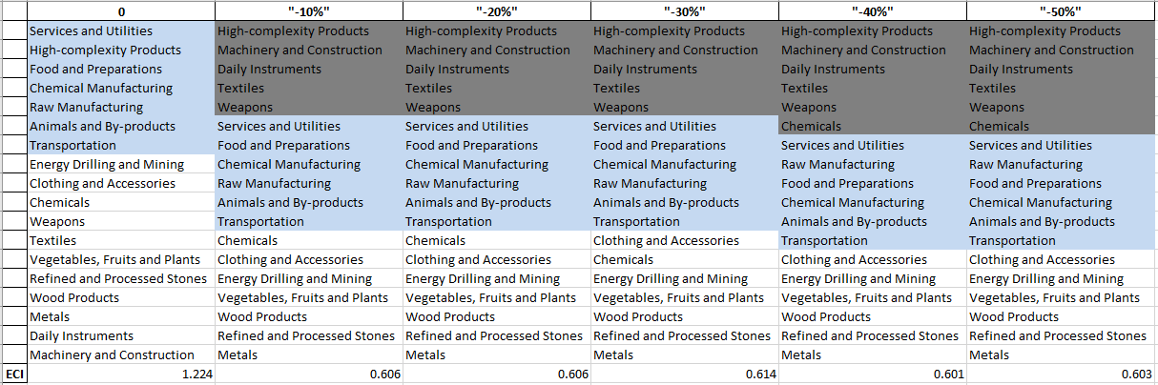

Table 19: France High-complexity Products 2014 (Decreasing Sensitivity)

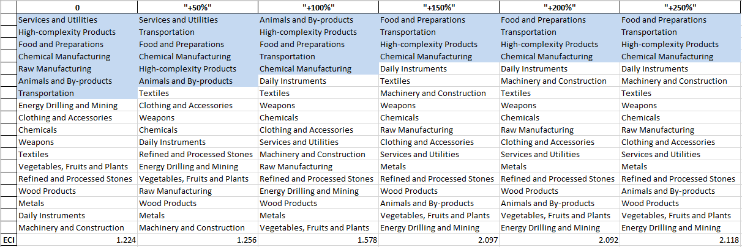

Table 20: France High-complexity Products 2014 (Incremental Sensitivity)

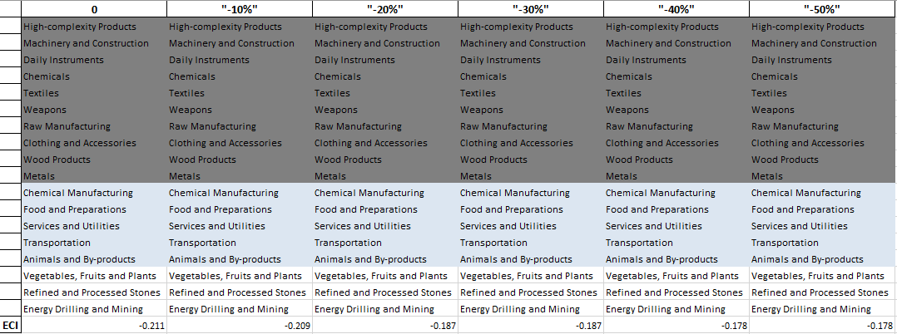

Table 21: France High-complexity Products 2009 (Decreasing Sensitivity)

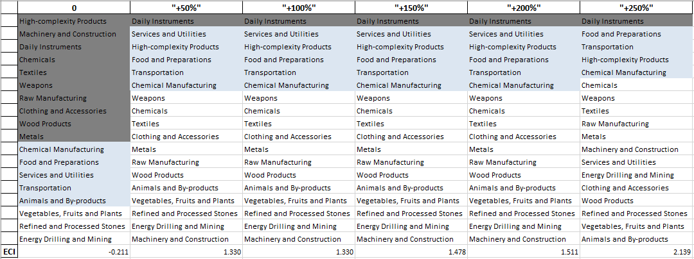

Table 22: France High-complexity Products 2009 (Incremental Sensitivity)

Decreasing export of each industry in France’s current production space by 60% respectively, we derive the contingency strategy shown below in Table 23,24.

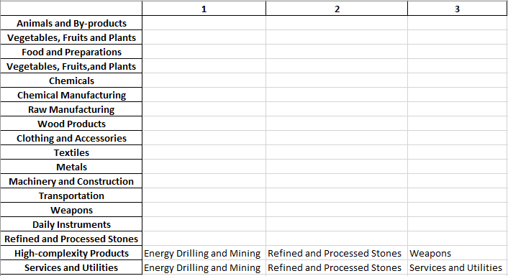

Table 23: Contingency Table of France during Industry Strikes 2014

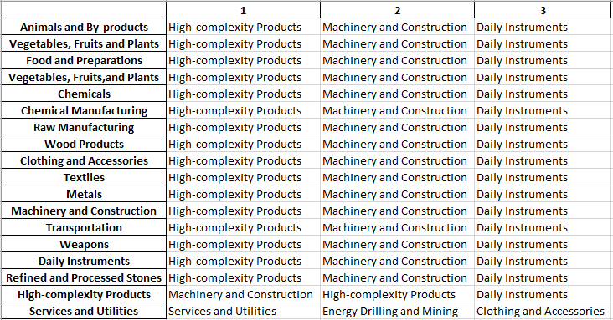

Table 24: Contingency Table of France during Industry Strikes 2009

5. Macro-level Predictions

5.1 Structural Optimality Index
Indeed, such choice of prioritization has proven to be a significant factor in deciding the economic outcomes of countries. In order to quantitatively evaluate how effective our developmental strategies are and how deviations from the suggested developmental path will lead to non-optimal growth results, we define the measure – Structural Optimality Index (SOI) – on a country level as the R-Square obtained from regressing the country’s actual development over the suggested development strategy. Both strategies are quantified in nature, with the actual development represented by export increase in major industry groups and the suggested development strategy represented by the opportunity gains of developing the corresponding industry groups as calculated in previous sections. The R-square from the regression thus provides us with a concrete measure of how the development path adopted by the country has fitted with/differed from our suggestion.

After obtaining this measure for all countries in our database, we further regress countries’ five-year economic growth, which as defined as the net increase in GDP (USD), over their SOI. Figure 6 illustrates the regression output, which shows a strong positive correlation between countries’ level of fitness and their five-year GDP growth, significant at the 1% level and achieving an adjusted R² of 11.9%. In other words, the more a country develops as suggested by calculations on a complexity level, the better economic outcomes it achieves.

Statistics | Value
Multiple R | 0.355
R-Square | 0.126
Adjusted R² | 0.119
Variable | Value
Coefficient | 1.249*10¹²
t-stat | 4.061
P-value | 0.000(***)


Figure 6: Regression of Five-year GDP Growth over SOI

5.2 SOI of France and Its Implications
France, for instance, has a relatively low level of structural optimality as compared with its developed peers. As the regression in Figure 7 suggests (the orange curve represents export increase and the blue curve stands for opportunity gain of the corresponding industry), France demonstrates a low level of correlation with the suggested developmental path, having an adjusted R-square of around 14.2%. France ranks the 34th place among all countries in terms of SOI and has an annual growth rate of merely 1.1% from 2009 to 2014, which is consistent with the regression result in Figure 6. This is in direct contrast to emerging economies such as China, where there is high SOI of around 82.8% and a corresponding GDP growth of 5.39 billion USD, making it one of the fastest developing economies during the period. In sum, France’s stagnant economic progress from 2009 to 2014 can be at least partially explained by a mismatched development strategy that demonstrates a considerable level of deviations from our suggested developmental path. In specific, France invested heavily in the transportation industry, while it should have focused more on industry groups such as service and machinery.
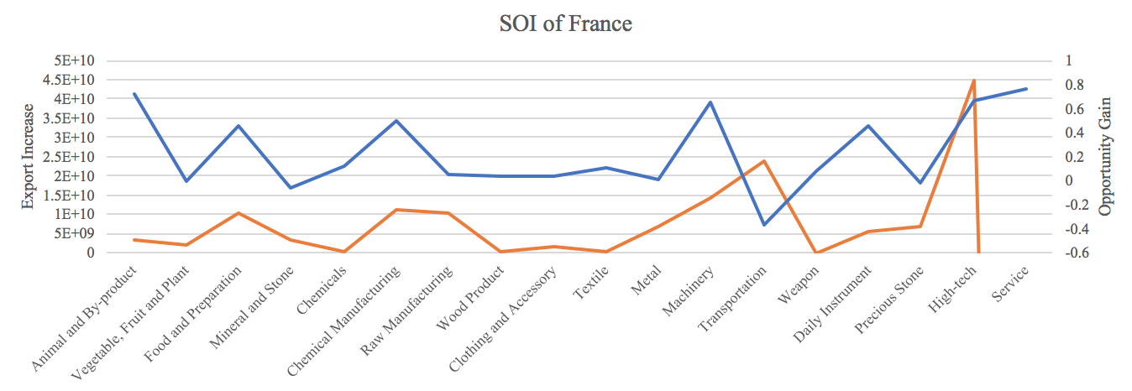

Figure 7: SOI of France (2009-2014)

6. Concluding Remarks

In conclusion, France has demonstrated a relatively low level of economic growth in terms of GDP during the period from 2009 to 2014, concurrent with a stagnation in economic complexity as compared with other major developed economies in the world.

The lack of economic progress during the period, we believe, can be partially explained through analysis of the economic and product complexity structure of France on the industry group level. The product classification system we adopt allow us to measure the actual development for various industry groups and to observe that France invested heavily in raw manufacturing and stone industry groups during the period, while its developed peers and emerging economies around the globe have adopted much more complex and progressive paths.

Based on our analysis of the opportunity gain and a sensitivity analysis of major industry groups, France could further its gains by prioritizing high-tech, machinery and daily instrument. We further note that France has a slightly mismatched development strategy that indicates a moderate level of structural optimality on the complexity level, having an adjusted R-square of around 14.2%. Since a significant positive correlation exists between five-year GDP growth and the structural optimality index of an economy as we define and calculate, France indeed has a suboptimal growth experience as compared with fast-growing economies both on a regional scale and on a global scale, and has the potential to further its economic gains through industrial structure optimization as suggested in the paper.

